##### **AWS INTERNSHIP TASK:**

# Step-by-Step Procedures:

##### Step 1: Launching a Windows EC2 Instance

* Click the “**Launch Instance**” button.
* Select a “**Windows Server**” AMI based on your requirements.
* In the instance type, set as “**t2.micro**” as a free tier eligible.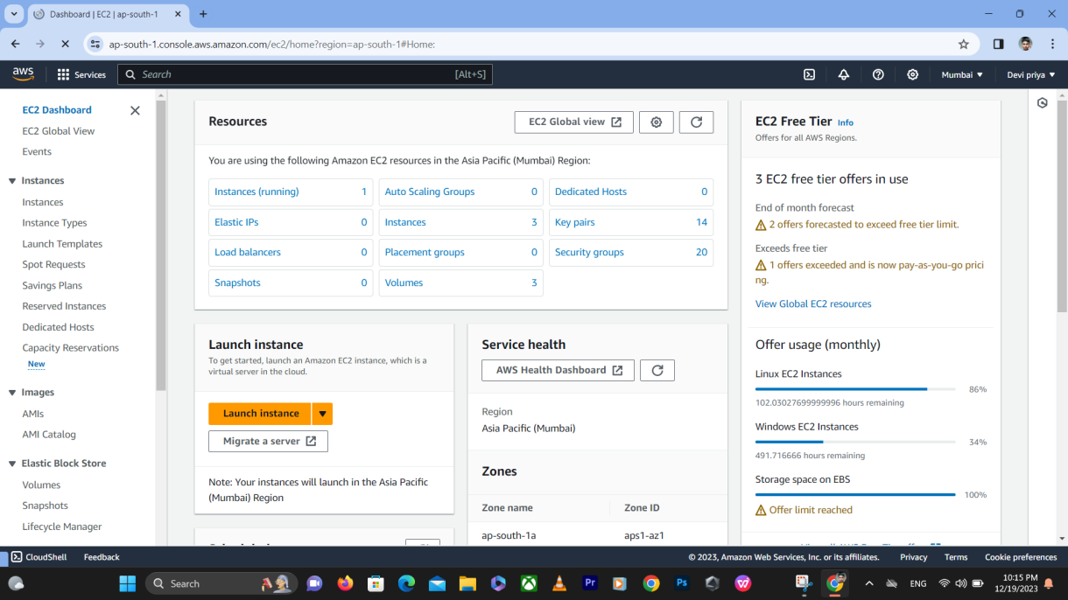

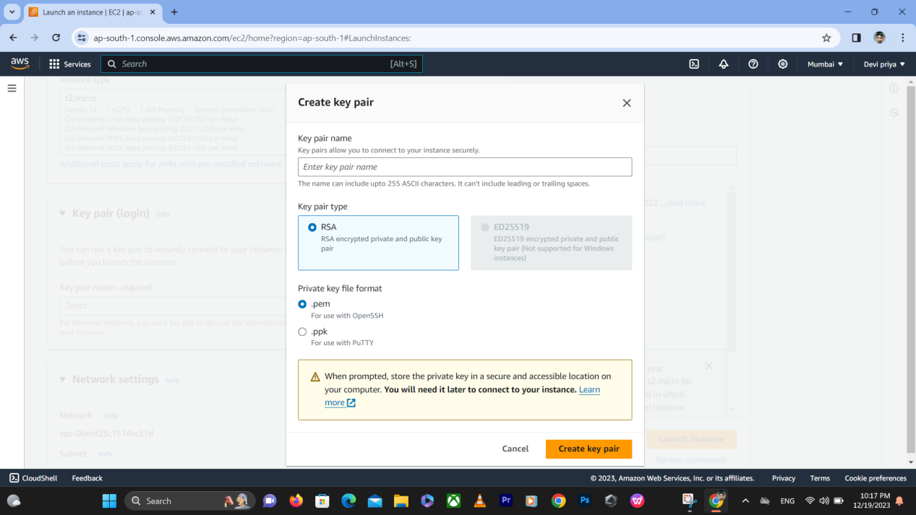

##### Step 2: Choose an existing key pair or create a new key pair.

* If you already have an EC2 “**key pair**“, select it.
* If not, create a “**new key pair**“. You’ll use this key pair to securely connect to  
  your Windows EC2 instance.
* “**Save the file**” on your local device. Make sure it is safe.

##### Step 3: Configure the Security Group and Virtual Private Cloud (VPC):

* Automatically “**assigned public IP**” should be “enabled”.
* Create a “**new security group**” or select an “existing one”.
* Define rules to allow **HTTP** (port 80), **RDP** (port 3389), and **HTTPS** (port 443)  
  traffic for a web server.
* Click “**Launch**” to proceed.

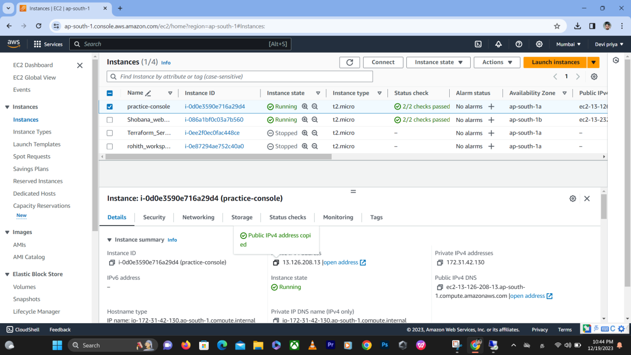

##### Step 4: Connect your EC2 instance

* In the RDP Client Tab, click on “**Download Remote Desktop File**” on your local machine.
* Click on “**Get Password**” and “**Upload the Private Key**“.
* Click on “**Decrypt Password**“, then copy your decrypted password.
* Open the RDP file and “**paste**” your copied decrypted password.
* You are successfully connected to your Windows EC2 instance.

##### Step 5: Windows Instance

* Navigate to the search bar for “**Server Manager**” and double-click to open.
* On the dashboard, on the left panel, click on “**Add Roles and Features**.”
* Click on “**next**” following Server Roles.
* Click on the “**web server (IIS)**” and click on “**Add feature**.”
* Finally, click on “**Install**.”

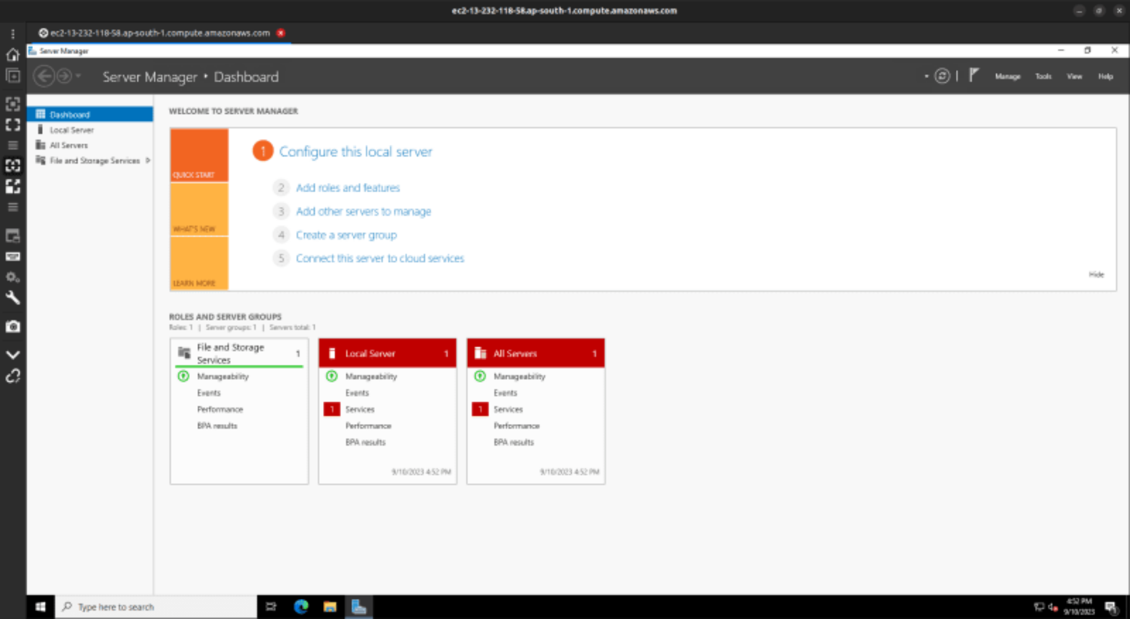

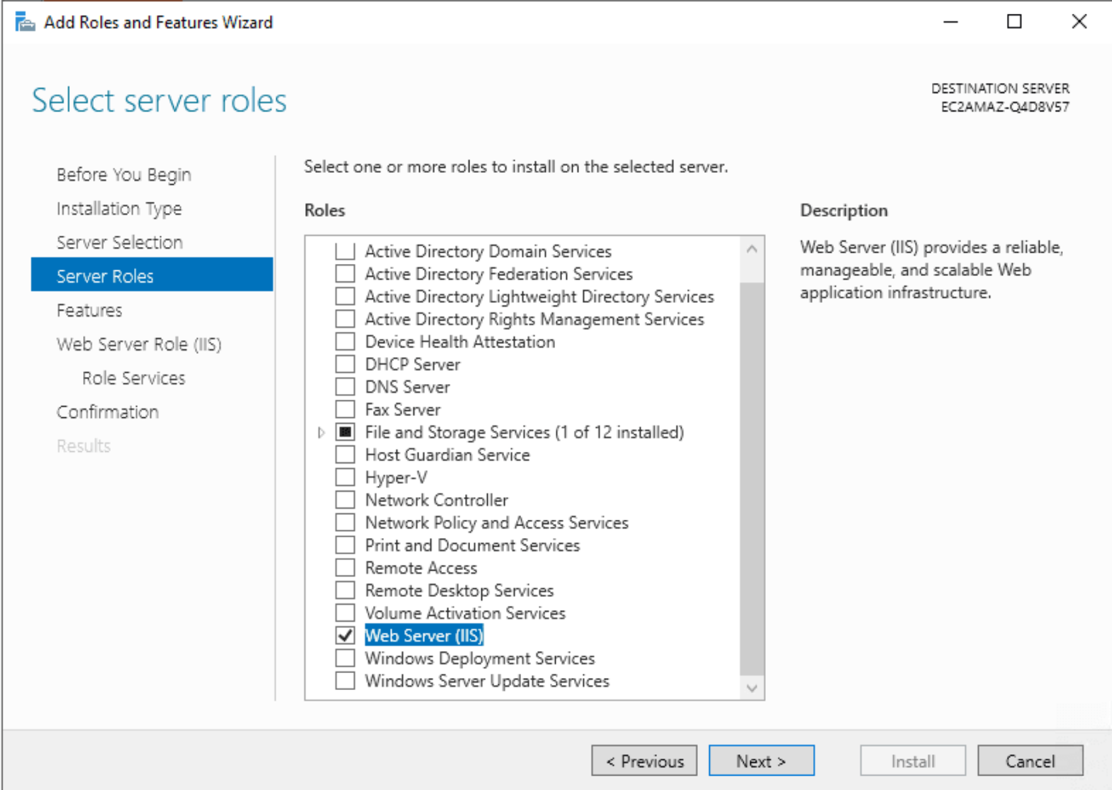

##### Step 6: Make a webpage file

* Navigate to “Local Drive (C:)” –> “inetpub” –> “wwwroot”. **Delete** all the files.
* Create a **new text document** and write, “This is my first static webpage.”
* Save it as “**index.html**“.

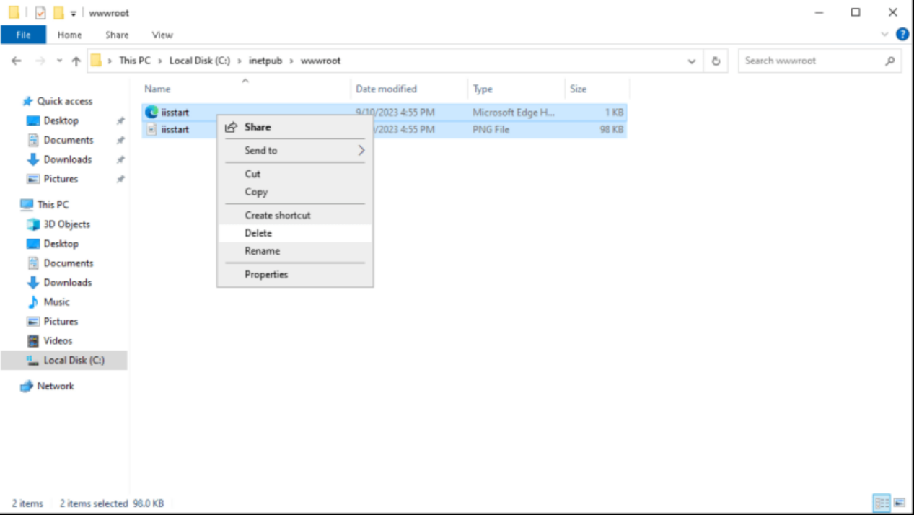

##### Step 7: Testing Your Static Website

* Copy the “**public IPv4 address**” and paste it into a new tab in your browser.
* The static webpage has been loaded successfully and can see, “**This is my first static webpage**.”

By this method I could able to host a webpage in AWS server. Hence my AWS internship task one is completed.